Minutes of the IQAC Meeting with Student Representatives held on 23/08/2022, 12.00, Seminar Hall
Agenda:
Disciplinary Measures in connection with Onam Celebrations scheduled for 30th August 2022
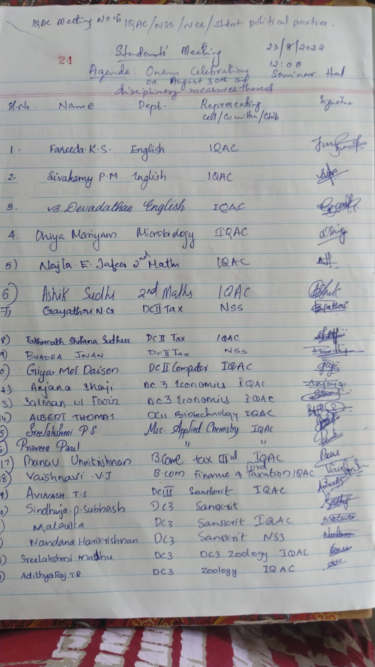

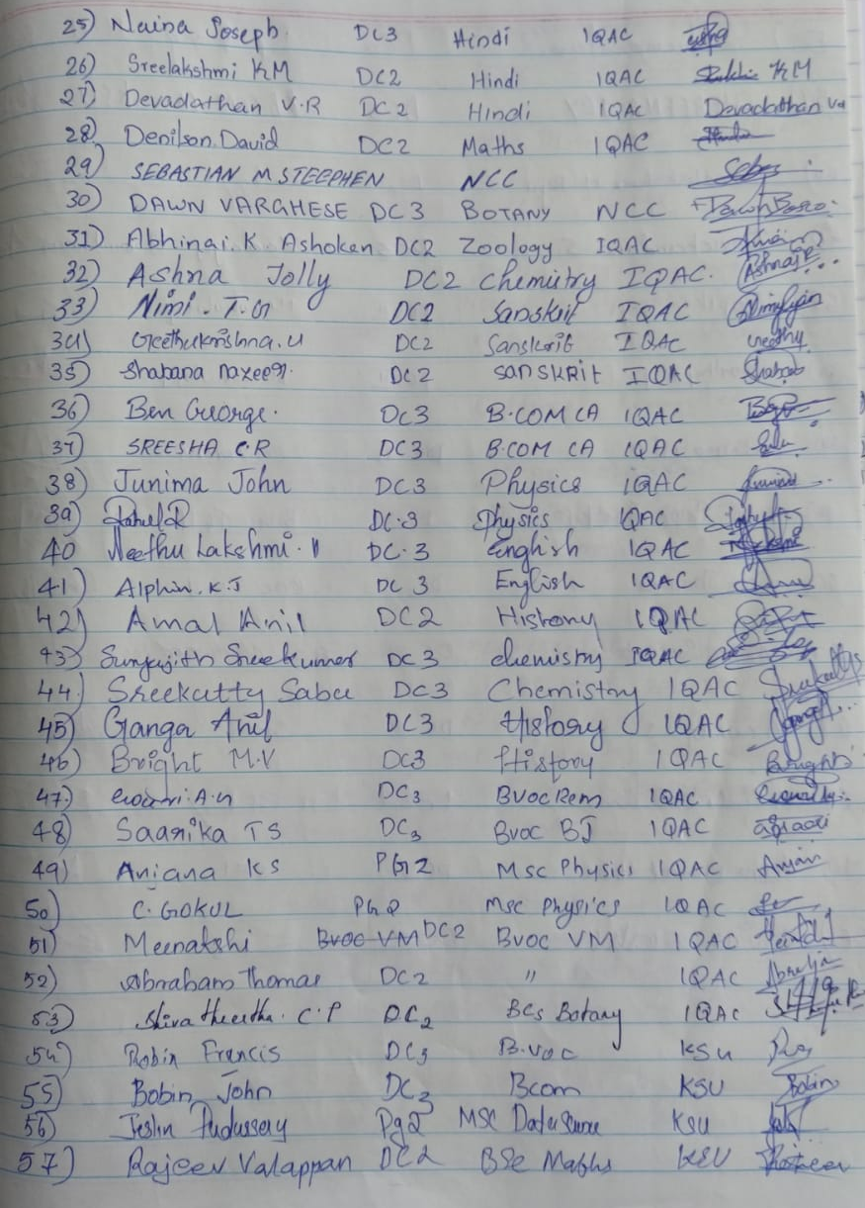
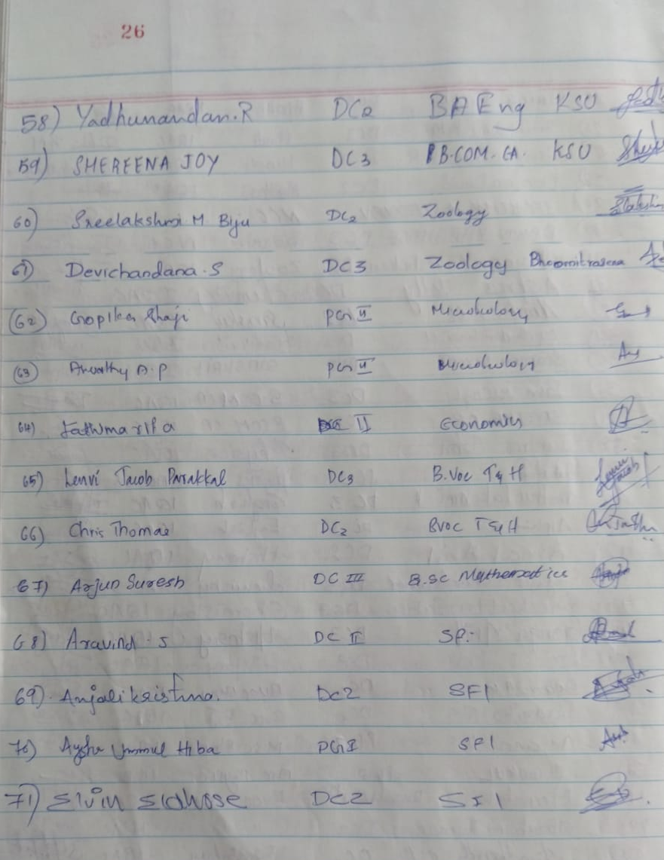
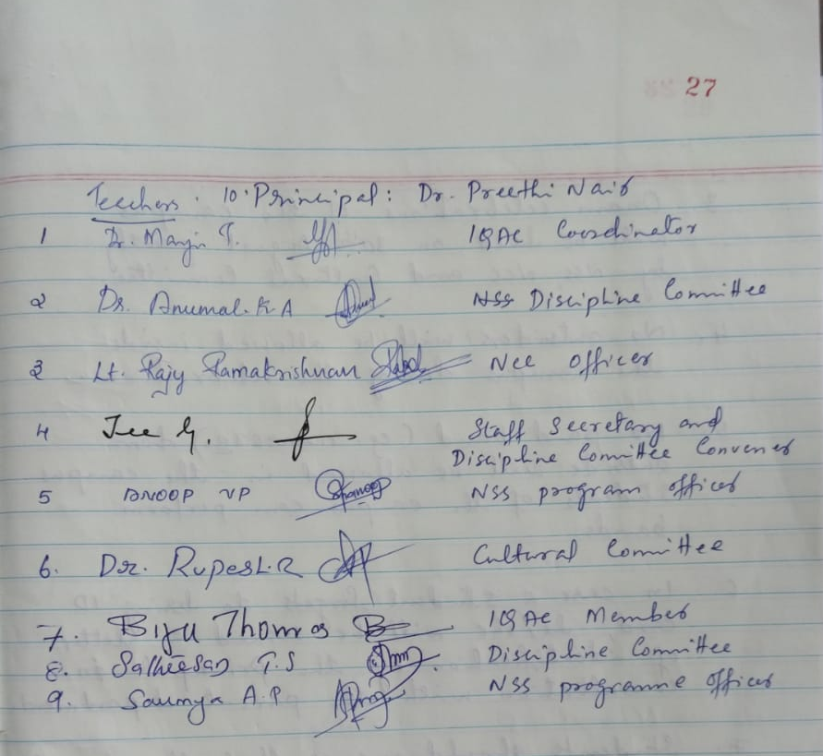
Points Discussed
Student representatives from NSS, NCC, Bhoomitrasena, IQAC and student political parties participated. The following points were discussed.
- Student ID cards declared mandatory especially during celebrations in the campus.
- The ID card must be produced by the student whenever asked for it inside the campus.
- Onam celebrations of the campus will be held on 30th August jointly by NSS, NCC and Cultural Committee.
- No outsiders will be allowed inside the campus during celebrations.
- No paid band from outside will be allowed in the campus. Students of the institute can perform bands.
- In case a student fails to bring ID card, he/she will be issued a letter of identification by the Principal in consultation with the parent department.
- Students should ensure that the dignity and decorum of the college will be upheld while celebrating this festival of unity.
- The meeting decided to conduct the following events:
  - Athappokkalam
  - Thiruvathira
  - Malayali Manga
  - Malayali Sriman
  - Ona Paattu
  - Tug of War (as demanded by students)
The meeting ended at 1.30 pm

